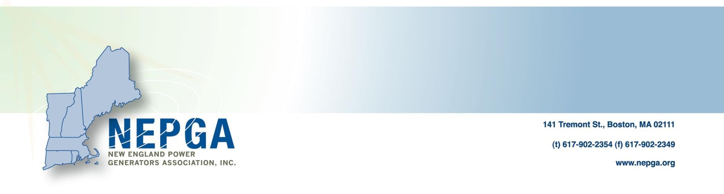

**TESTIMONY OF**

**DAN DOLAN**

**ON BEHALF OF**

**NEW ENGLAND POWER GENERATORS ASSOCIATION (NEPGA)**

**2015 – Senate Bill 1788 and Senate Bill 1789**

**JOINT COMMITTEE ON ENERGY AND TECHNOLOGY**

**September 22, 2015**

I write today with concerns on S 1788 and S 1789. Although there are a number of important issues and concerns with impacts of retiring power plants on host communities, I do not believe that these bills provide an appropriate framework for addressing them.

I am the President of the New England Power Generators Association, Inc. (“NEPGA”),1 the trade association representing competitive electric generating companies in New England. NEPGA’s member companies own approximately 25,000 megawatts (MW) of generating capacity throughout New England, and over 11,000 MW of generation in Massachusetts, or nearly 85 percent of the electric generating capacity within the Commonwealth. Our mission is to promote sound energy policies which will further economic development, jobs and balanced environmental policy.

NEPGA’s Massachusetts companies provide power to the state from a diverse portfolio of plants, including natural gas, coal, oil, hydro, and nuclear. Overall, the companies pay over $71 million annually in state and local taxes, while providing over 1,400 well-paying and skilled Massachusetts jobs. Our companies are good corporate neighbors, contributing to the civic and charitable endeavors of their host communities, donating nearly one million dollars annually to charitable endeavors throughout the state.[1]

**I. NEPGA’s Position**

While NEPGA certainly appreciates the important policy issues raised by S 1788 and S 1789, NEPGA has some concerns regarding certain issues raised by these bills for the decommissioning of facilities in the Commonwealth. Power plants occupy an important role in their host communities with the potential retirement or new development of a plant having numerous implications. Power plants also represent some of the last large manufacturing facilities in Massachusetts; they provide well-paying jobs coming from investments made by owners in response to economic signals, much as any other manufacturing is developed. These facilities are also often among the largest taxpayers and employers in their communities. While perhaps not intentionally, some of the provisions in S 1788 and S 1789 may unnecessarily limit options for the best use of a site and may inadvertently make it more difficult for appropriate investments in power generation facilities to occur at the sites of retiring power plants or other locations across the Commonwealth. Additionally, these bills seek to treat facilities that manufacture electricity more stringently than all other manufacturing facilities in the state are treated.

**II. Adequate State and Federal Environmental Requirements Exist**

To the extent that these bills seek to address policy concerns regarding reliability and environmental concerns relating to plant closures, there are state and federal requirements already in place that govern those issues. For example, due to the unique nature of the fuel used for generation, all nuclear generating plants have decommissioning requirements as part of their Nuclear Regulatory Commission (NRC) licensing process. For non-nuclear plants, any retirement or decommissioning approach taken by an owner is subject to the state and federal environmental requirements to which all manufacturing facilities would be subject, including but not limited to reliability determinations, site remediation and other environmental impacts.[2]

**III. A Focus on Collaboration and Communication**

As the New England energy industry transitions, NEPGA appreciates the desire of policy makers to ensure that an orderly process is in place for existing generating facilities that may be retired over the coming years. Instead of requiring owners of certain generation to submit a definitive plan for their facilities immediately upon retirement, NEPGA believes it is better to maintain flexibility for the private owners to determine the best use of a site. Encouraging communication between owners and their host community immediately prior to an announcement of retirement, after an announcement and during the transition period would be a better policy focus. Moreover, NEPGA strongly supports any efforts focused on the redevelopment and reuse of existing facilities through community-based development. The model that was developed in Massachusetts for handling plant closures through the Salem Harbor Power Station – Revitalization Task Force is one that can be used as a guide moving forward.[3]

**IV. Conclusion**

NEPGA certainly appreciates the desire of policy-makers to ensure that at the time an electric generating facility may decide to cease operation that there is an orderly transition process, but state and federal law already provide such protections. Imposing additional requirements or restrictions, however, well-intended, may unintentionally place the Commonwealth at an economic disadvantage for attracting any new investment or redeveloping existing facilities. Likewise requiring an existing retiring site either to sell, transfer or repower or submit a detailed decommissioning plan for approval is unnecessary in light of existing federal and state guidelines for all manufacturing facilities which already govern closures. For these reasons, NEPGA asks the Committee not to pass S 1788 and S 1789.

1. The views in this testimony reflect those of NEPGA and not necessarily the position of each individual member.
2. NEPGA has not included an exhaustive analysis of such measures in this letter, but is certainly willing to provide such information to the Committee upon request if the members believe such information would be helpful.
3. <http://www.mass.gov/anf/docs/anf/fy14/fy2014-budget-attachment-f-rggi-201307121330.pdf>, <http://www.mass.gov/eea/energy-utilities-clean-tech/salem-harbor/>